WORK & PENSIONS SELECT COMMITTEE

Inquiry into the Work of the Health and Safety Commission and Health and Safety Executive

Joint Memorandum by:
Health and Safety Commission and Health and Safety Executive
February 2004

CONTENTS
 | Paragraphs
Introduction | 1-6
Constitutional framework | 7-10
Legal framework | 11-17
Achievements since 1974 | 18-21
Revitalising Health and Safety | 22-26
Strategy for workplace health and safety | 27-34
Our approach to regulation | 35-43
Delivery through programme working | 44
Resources | 45-49
 | Pages
Annex 1 – Progress against Revitalising targets | 13-14
Annex 2 – Building of success:  A broad range of intervention strategies | 15-17
Annex 3 – The balance between  prevention and enforcement | 18-20

SUMMARY
This memorandum sets out the context of our work, describing achievements to date, and the way we are adapting to a changing economy. The introduction of the Health and Safety at Work etc. Act in 1974 established both the Health and Safety Commission and Health and Safety Executive, providing a framework of accountability to the Secretary of State and effective corporate governance for the Executive. The Act signalled a new era; the ‘goal setting’ approach to health and safety reflected in the Act was seen by Government as an enabler of innovation, and that approach continues to stand the test of time.

Since introduction of the Act, our work has made a substantial impact, contributing to a reduction in workplace fatalities of more than two thirds. In response to a slowing rate of improvement in the1990s, Revitalising Health and Safety was launched, setting bold targets and recognising occupational health as a crucial issue. By 2003 it was clear that more had to be done, and our new strategy for workplace health and safety to 2010 is the result. This defines a more proactive approach, with four high level themes of partnership, support, targeting our resources, and communicating effectively. These are aimed at encouraging good practice and increasing understanding of health and safety requirements.

This memorandum explains our approach to regulation (including in the major hazard industries), following the better regulation principles. We do not see new regulation as the automatic response to new issues or changing circumstances, but will continue to press for higher fines, a new law on corporate killing and the removal of Crown Immunity. We also explore in an annex to this memorandum the difficult issue of finding the correct balance between prevention and enforcement.

The memorandum describes the current resource position of Health and Safety Commission and Executive and the pressures upon it. A programme of efficiency savings and cost reductions aimed at freeing up resources for increased operational output has been implemented in response to these pressures.

Introduction
- This Memorandum sets out briefly the constitutional, regulatory, strategic and operational context of the work the Health and Safety Commission (HSC) and the Health and Safety Executive (HSE). Our mission, working with local authorities (LAs), is to protect people’s health and safety by ensuring that risks in the changing workplace are properly controlled.

- We welcome this inquiry, which comes at a time of development and change. In 2002, as a result of Machinery of Government changes, the Department for Work and Pensions (DWP) became our parent Department. We view this as a positive move with important synergies between our preventative mission and DWP’s responsibilities to support an active workforce and to help people into or back into work. We are pleased with the constructive way our relationship has been developing.

- We are proud of our achievements since being established in 1974 and this Memorandum offers some highlights. We view as a vote of confidence the recommendations from successive public inquiries to pass regulatory responsibility to us for an increasing number of major industries. The most recent Cullen Inquiry into the Ladbroke Grove rail accident confirmed the view that we remain the right home for the independent health and safety regulation of the rail industry.

- The Health and Safety at Work etc. Act 1974 (the Act) was welcomed by both sides of industry and continues to enjoy their support. We work closely with businesses and with unions as representatives of workpeople. Our consultation processes cover a wide range of stakeholders appropriate to the issue in hand, and special efforts are made to engage groups that are harder to reach, such as small businesses. We also attach the highest importance to engaging the whole workforce for they are the ones who are exposed to the risks and best placed to identify them. As testimony to this commitment, HSC will shortly be launching a Statement that promotes worker involvement and consultation.

- That said, we are not resting on past glories. The working environment has been changing rapidly and in 2003 we undertook a major evaluation of our approach. As a result, HSC recently agreed a new forward looking strategy which was formally launched on 23 February 2004. This has important implications for us and for the rest of the health and safety system. It shows health and safety as an enabler, not a hindrance. It is good for employment and productivity, it contributes to the government’s agenda on health, rehabilitation and health inequalities, and it can enhance public sector delivery.

- The strategy also makes clear that we are not seeking a risk free society but one where risks are properly understood and managed. We will achieve this through a sensible and proportionate approach. We will also use this to counter the myths and stories about our alleged ‘risk averse’ approach.

Constitutional framework
- The independent enforcement of health and safety has been a feature of the regulatory system in Great Britain for more than 150 years. The modern system owes its origins to the Robens Committee of Inquiry and the subsequent passing of the Act. This established HSC and HSE as two separate non-Departmental Public Bodies accountable to the Secretary of State. It also confirmed a role for LAs in health and safety enforcement.
- HSC has overall responsibility for policy on health and safety, and, uniquely among other government regulators, advises Ministers on relevant standards and regulations. It also conducts research and provides information and advice. The Chair and members of the Commission are appointed by the Secretary of State for Work and Pensions following consultation, advertisement and open competition.

- Although legislative responsibility for occupational health and safety is reserved to Westminster, health more generally has been devolved to the Scottish Parliament and Welsh Assembly. HSE has evolved its structure to enable the development of close working relationships with the devolved administrations.

Corporate governance of HSE
- HSE advises and assists HSC and has a statutory responsibility to make adequate arrangements for the enforcement of the Act and other relevant statutory provisions in Great Britain. The Act sets out the corporate governance regime for the HSE. Broadly speaking, HSC provides non-executive oversight of HSE. HSE implements its share of the HSC work plan, itself approved by Ministers, and exercises a number of functions delegated to it by HSC. HSE’s responsibility for enforcing the Act is carried out in accordance with the Enforcement Policy Statement (www.hse.gov.uk/pubns/hsc15.pdf), set by HSC after full consultation with stakeholders. Individual Commissioners are increasingly engaged in monitoring HSE’s performance in particular areas and a Commissioner has recently taken on the role of chairing HSE’s Audit committee.

Legal framework
- The Act sets out the general duties that employers have towards employees and members of the public, those that employees have to themselves and to each other, and the duties of the self-employed. A fundamental principle of the legal framework is that responsibility for health and safety lies with those who own and manage workplaces, or who work there, including the self-employed. They must assess the risks attached to their activity and take appropriate action. This ‘goal setting’ rather than ‘prescriptive’ approach takes account of what is reasonably practicable and encourages innovation. Regulations made under the Act can be supported with Approved Codes of Practice that detail how employers can comply with the law.
- In its strategic review of health and safety in 2000 (Revitalising Health and Safety; see paragraph 22), the Government considered that the basic framework of the Act had stood the test of time and remained relevant for the future. In the ‘Innovation Challenge’ report (December 2003) the DTI called for more ‘outcome’ based Regulations to encourage innovative compliance, and undertook ‘to work more closely with HSE in promoting health and safety as an enabler of innovation’.

- HSC does not see new regulation as the automatic response to new issues or changing circumstances, but does believe that imposed fines are too low (the conclusion of the Court of Appeal in R v Howe 1998); large company health and safety fines being up to ten times lower than the general level of financial services fines for larger companies. HSC will continue to press for higher fines, a new law on corporate killing and the removal of Crown Immunity.

- Further background on the health and safety system, and the roles of HSC, HSE and LAs within it, can be found in the document Health and safety system in Great Britain (www.hse.gov.uk/pubns/ohsingb.pdf)

Influence of the European Union
- The development of health and safety legislation in Great Britain has been significantly influenced by the European Union (EU). A key element was the Framework Directive (EEC/89/391), which established broadly based obligations for employers to evaluate, avoid and reduce workplace risks.

- Following approval of a Ministerial mandate, HSE negotiates in European discussions to ensure consistency and proportionality in legislation, to achieve improvements where justified by risk, and to promote better standards across Europe. When European legislation has been agreed, HSE’s approach is to implement Directives without the addition of unnecessary extra requirements.

- In July 2003 the Government received a Reasoned Opinion from the European Commission, alleging under-implementation of the Framework Directive relating to the use of ‘so far as is reasonably practicable’ in our legislation. A reply has been sent to the Commission and their reaction is currently awaited.

Achievements since 1974
- The achievements of HSC and HSE, working with LAs, since the introduction of the Act have been very substantial. The accident levels highlighted in Robens’ report make stark reading. For instance, in 1974 there were 651 fatal injuries to employees in production and some service industries. The comparable figure for the year 2002/03 is 182, a reduction of over two thirds. Figure 1 presents the number and rate of fatal injuries to workers, i.e. employees and self employed, since 1974 and clearly illustrates this continuing improvement. That said, Figure 1 also illustrates the point that the rate of improvement has been gradually slowing to a plateau during the 1990s.

Figure 1. Number and rate of fatal injuries to workers 1974 to 2002/03
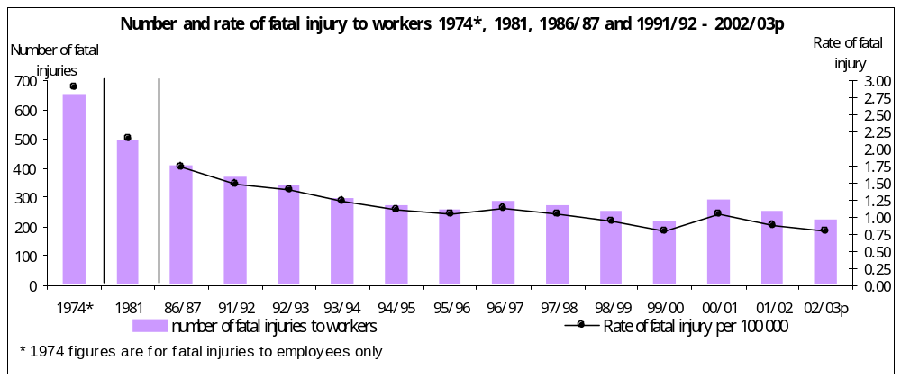
- On ill health trends, very few sources provide a consistent basis back to 1974. Since 1990, information on work-related illness based on self-reports has been available from a series of surveys linked to the Labour Force Survey. Overall data for England and Wales are shown in Figure 2.

Figure 2. Health data for England and Wales since 1990
I 95% confidence interval
- Comparisons suggest that, over the past decade, the overall rate of self-reported work-related illness prevalence has fallen. The estimated prevalence rate of stress and related (mainly heart) conditions has increased over time and is now around double the level it was in 1990.
- Great Britain’s achievements in health and safety performance are also commendable on an international basis. Though some care is needed when making comparisons between countries, the EU has published the chart, reproduced in Figure 3 below, showing the annual rate of workplace fatalities in 14 Member States (2000 figures). On this basis Great Britain has the second lowest rate of 1.7 per 100,000 workers compared with the EU average of 2.8.

Figure 3. EU comparisons for rate of fatal injuries
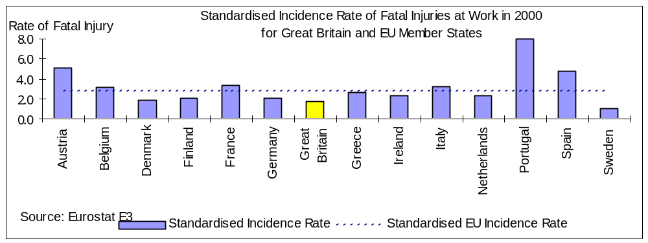

Revitalising Health and Safety
- In 1999, with the Act operational for 25 years and the rate of improvement in national performance clearly slowing, the Government and HSC instigated a major review. The Revitalising Health and Safety strategy statement, launched by the Deputy Prime Minister and the HSC Chair in June 2000, signalled a need to ‘re-energise’ the system and set national targets for improving health and safety performance (www.hse.gov.uk/revitalising/index.htm). These were by 2010 to reduce:
- the incidence rate of fatalities and major injuries by 10%;
- the incidence rate of cases of work-related ill health by 20%;
- the number of working days lost per 100,000 workers from work-related injury and ill health by 30%;
and to achieve half the improvement under each target by 2004.

- We responded to Revitalising by identifying eight areas for priority action, chosen on the basis of maximum likely impact on the targets. Two of these priority areas were the emergent health issues of stress and musculo-skeletal disorders which now comprise a large proportion of all self-reported illness, as shown by Figure 2.

Progress with targets
- There is no conclusive evidence as yet of the extent of progress towards the first target. A programme of research into underreporting of major and over-3-day injuries is underway, and is designed to tell us more about recent changes in the reporting of major injuries.
- On the overall incidence of work-related ill health, the balance of evidence suggests that it is likely to have risen since 1999/2000, although this may be due to an increasing awareness of work related ill health problems such as stress that previously may not have been attributed to work. On the last target - days lost due to workplace injury and ill health - it is not yet possible to make a judgement on progress, as figures are available for one year only. Further charts relating to progress with targets are at Annex 1.

- The conclusion at present must be of limited progress towards targets, based on currently available hard evidence. However, because there is inertia in the system, ie a time lag between actions taken and response in terms of progress towards targets, some proxy indicators have been developed for the purpose of quarterly reporting to Ministers. Measured against these indicators, we are starting to show some early gains.

Strategy for workplace health and safety
- The Revitalising targets stimulated a new approach in HSC and HSE to tackle the ‘performance plateau’, but it became clear that more had to be done to mobilise the whole health and safety system if targets were to be achieved. A key challenge was to make appropriate risk management relevant to the modern world of work. Since 1974, the workplace, employment trends and public attitudes to risk and redress have changed significantly.

- As a first step, HSC adopted a new vision in early 2003. That vision is to gain recognition of health and safety as a cornerstone of a civilised society and, with that, to achieve a record of workplace health and safety that leads the world.

- The development of a new strategy followed. It supported Revitalising and recognised the following key drivers for change:
- a perception that there is no coherent direction to the overall health and safety system. HSC, HSE and LAs cannot or should not do it all;
- HSE and LA resources are limited, spread too thinly and need to be targeted to where they can have the most impact;
- HSC, HSE and LAs have done a great job on safety but there is still a huge job to do on health;
- many organisations are motivated to make improvement but do not turn to HSE and LAs for advice;
- long-term gains need hearts and minds not grudging acceptance.

- HSC’s new strategy followed extensive consultation, has been endorsed by Ministers and was formally launched on 23 February 2004. Copies of the published document, A strategy for workplace health and safety in Great Britain to 2010 and beyond, are provided for Committee members. It can also be accessed on the HSE website at (www.hse.gov.uk/aboutus/hsc/strategy.htm).

- This strategy signals a new approach. First, we cannot do this alone. We need to understand and value more the contribution of others and work with them in robust new partnerships. This includes using our links with DWP to best effect in emphasising rehabilitation and getting people back to work.

- Second, we need to work better and smarter to support the whole health and safety system and create a greater understanding of its concepts. Trade union workplace representatives operating in partnership with management are an important part of realising health and safety benefits. We also need to:
- promote the business case;
- make risk assessment more useable as a concept;
- develop nationally available occupational health support;
- simplify our advice and guidance wherever we can;
- do more to encourage others to develop and promulgate good practice.

- Third, we need to be clear about our priorities and focus our activities on our core business and the right interventions. This means concentrating more on the areas and interventions where we can make the greatest impact, and developing new ways to exert influence. The draft work-in-progress document at Annex 2 offers some illustrative examples. The focus on priorities also means determinedly moving away from intervening in those areas of public safety that are better regulated by others or by other means – including civil law.
- Last, we need to be more effective in communicating our vision and making clear that we are not seeking a risk free society but one where risks are properly understood and managed. We recognise that we must be more mature, open and inclusive in our communications. We must deliver our advice and guidance in ways that small businesses, for instance, find easy to assimilate, and make best use of intermediaries.

Our approach to regulation
- Our approach is informed by the principles of better regulation: transparency, accountability, targeting, consistency and proportionality. This approach is set out in the Commission’s Enforcement Policy Statement (see paragraph 10). HSE has established memoranda of understanding with other regulators to ensure that potential boundary issues, overlaps and omissions are properly addressed.

- The National Audit Office is due to report in the near future on an audit of HSE’s construction strategy and programme, and have been considering whether:
- it is appropriate and based on sound evidence;
- it is making an impact on the control and management of health and safety risks; and
- the barriers to improvement in the health and safety record of the industry are being tackled effectively.
While this audit is confined to a specific, albeit major industrial sector, it may provide an insight into HSE’s wider regulatory approach and achievements.

The balance of preventative and reactive intervention techniques
- There is strong evidence to support the continuation of a balanced mix of advice (persuasion), enforcement and business incentives. Enforcement is an effective means of securing compliance. It creates an incentive for self-compliance and a fear of adverse business impacts, such as reputation damage, in all sectors and sizes of organisations. There is also evidence that enforcement and HSE leadership is an important element in prompting major hazard firms to manage health and safety, including major accident prevention. There is some evidence that advice and information are less effective in the absence of the possibility of enforcement.
- The question raised by the Committee, of the balance between prevention and enforcement, is a critically important one for HSE and for LAs. However, the three areas of activity encompassed by those terms - proactive work, reactive work and enforcement - share a common preventive purpose. The essential question therefore is about how to apply them to best achieve this purpose while satisfying public expectations of and demands upon HSE. In recent years the trend has been towards spending more time on investigation, to the detriment of proactive work, and to a degree which HSE now believes is not the best use of the available resources. Given that our primary purpose is to prevent harm through improved standards, the organisation is now acting to redress that balance towards proactive work. These issues are elaborated at Annex 3.

Regulating major hazard industries
- Regulating major hazard industries forms a significant part of our responsibilities. These industries have the potential to cause catastrophic events or major accidents involving fatal or serious injury to significant numbers of people. We aim, working with business, to prevent these catastrophic failures and major incidents. We work largely through a system of prior approvals and permissioning based on the submission by operators of safety cases. This gives us the opportunity to ensure that arrangements exist which, if adhered to, will provide for adequate management of risk.

- HSC and HSE were created in the immediate post-Flixborough era and, since then, our strategies and operational procedures for regulating major chemical sites have proved successful. Our approach has also been highly influential in Europe. Responsibility for safety at nuclear installations also transferred on our formation. This too is a success story of close scrutiny and no major events. The same can be said of the offshore oil and gas industry, responsibility for which transferred to us in 1990 in the wake of the Piper Alpha tragedy.

- Full responsibility for safety on the railways was also transferred to us in 1990. This has been a more complex story and the regime for rail has been the subject of much recent scrutiny. At the turn of the year, HSE submitted evidence to the Transport Select Committee’s inquiry into the future of the railways. On 19 January, the Secretary of State for Transport announced a major review of the structure of Britain’s railways. Our input to the review will spell out the strengths of HSE’s approach and will emphasise key principles such as the importance of an independent safety regulator, and of a satisfactory interface between worker and public safety. One piece of evidence we have submitted to this review is a chart which plots the annual number of significant train incidents per million train miles from 1975 to the present time. This standardised index has fallen from 0.53 in 1990/91 to 0.20 in 2002/03.

The future
- We intend to take a proactive approach to the future of health and safety regulation by examining our role as a regulator and how we are responding to the changing economy around us. We are approaching other regulators, such as the Food Standards Agency and the Environment Agencies, to see if we can achieve a common view about the best way forward.
- We are also evaluating the current enforcement approach and consulting stakeholders on what they see as the key enforcement issues. As the fear of enforcement is a significant motivator for organisations, there is value in exploring whether alternative approaches or sanctions could help improve impact. This will include the extent to which restorative justice may prompt offending organisations to change their behaviour.

Delivery through programme working
- HSE is developing its planning and governance arrangements to ensure that the business and the deployment of resources are oriented to delivering strategic priorities. This puts in place structured delivery management based on best-practice programme working. This is overseen by a new HSE Delivery Board, chaired at Executive level.

Resources
- We are funded mainly by grant from DWP. We also receive money from charging for aspects of our work – mainly in relation to regulating major hazard industries and through sale of publications. We have some freedom to increase activity levels where work is funded by charging, but our net budget is set by DWP through the Spending Review process. The table below shows the overall budgetary position up to 2007/08

 | 2001/02 | 2002/03 | 2003/04 | 2004/05 | 2005/06 | 2006/07 | 2007/08
 | £m | £m | £m | £m | £m | £m | £m
Gross Budget | 254 | 262 | 278 | 279 | 271 | 271 | 271
Income | 51 | 52 | 58  forecast | Income level subject to further work on charging
Gross Spend | 255  (outturn) | 256  (outturn) | 260  forecast

Notes
1. SR2004 projected budget (06/07 and 07/08) assumes roll forward of 2005/06 baseline.

2. The ring-fenced Cullen funding of £4m is included in figures for each of years 03/04 and 04/05.

- Following a period of modest increase in resources, Spending Review 2002 set a baseline which rises slightly in 2003/4, and 2004/5 and drops back in 2005/6. When rising costs are taken into account this represents a significant reduction in spending power.

- To meet this we have adopted a financial strategy of efficiencies and cost reductions. The objective has been to reduce spend below budget now, and build up funds to help bridge the gap in 2005/06 and beyond. For this reason the table above shows gross spend as less than gross budget for the years 2002/02 and 2003/04. The efficiency programme has been aimed at freeing up resources for operational activity, while increasing operational productivity.

- The table below details HSE’s staff numbers for 1999-2004

Staff In Post Data 1999-2004
 | April 1999 | April 2000 | April 2001 | April 2002 | April 2003 | January2004
Total Staff HSE/HSL | 3880 | 3937 | 4081 | 4282 | 4162 | 3995
Agency Staff constituent | N/A | N/A | 187 | 232 | 94 | 85
No of Inspectors | 1497 | 1507 | 1534 | 1625 | 1651 | 1619

- The Trade Union, Prospect, have campaigned for increases in HSE inspectors, particularly in the Field Operations Directorate (FOD). Inspector numbers fluctuate, particularly as staff are recruited into FOD but, when experienced, may move into more specialised work elsewhere. FOD are piloting new approaches where visiting administrative staff work alongside inspectors in frontline roles, delivering key health and safety messages. There are now some 60-70 such administrative staff, and their work enables inspectors to spend more time targeting the dutyholders most in need of HSE's attention. This more efficient approach to deployment of frontline staff will be extended across the whole of FOD, as resources allow.

Contact:
Phil Kemball
Health and Safety Executive
Rose Court (Floor 8 North Wing)
2, Southwark Bridge
London SE1 9HS
020 7717 6725
phil.kemball@hse.gsi.gov.uk

Annex 1

Progress against Revitalising targets

Injury target
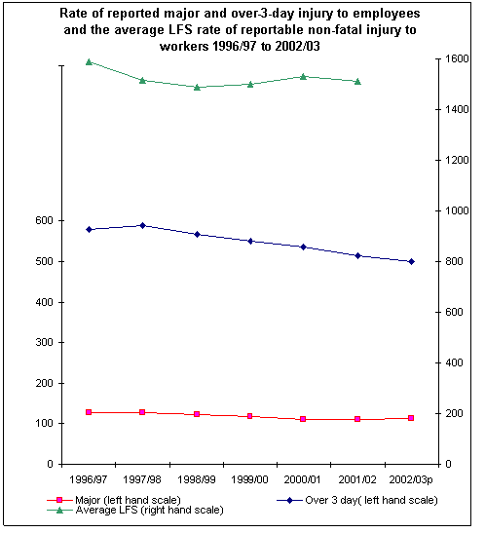

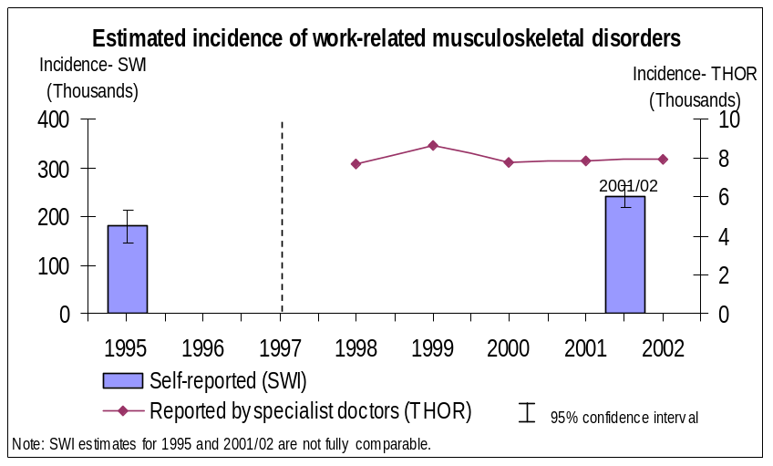
Ill Health Target

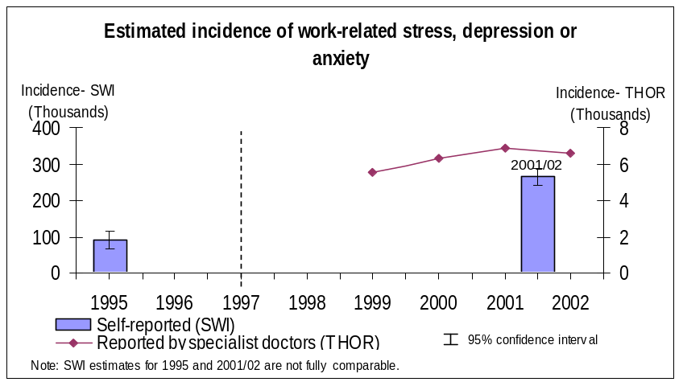

Annex 2
Building on success: A broad range of intervention strategies
A working draft for development between Local Authorities and HSE

Editorial note

As the subtitle above indicates, this is a draft document that will be developed jointly with LAs, to support the closer working in partnership envisaged by the new Strategy. It does not at this juncture contain detail about the intervention strategies that it outlines. It was drafted with non-major hazard activities in mind.

This statement sets out key principles for using to best effect all the available tools and techniques for continuing to drive improvements in standards of health and safety and lists the main intervention strategies.

The first principle is a fresh emphasis on encouraging duty holders to do more to improve health and safety by updating and improving the financial and other arguments to persuade duty holders that good standards will help their business.

The second principle is to be vigorous and consistent in going beyond compliance assessment and enforcement to make full use of other intervention strategies; but to be very clear in dealings with duty holders to distinguish between what the law can compel them to do, and what regulators and others in the health and safety system can encourage them to do.

The following strategies, often applied in combination, may be used to combat risk at three points of opportunity.

1) Before, and at the point of creation, of risk

Partnerships
~ Strategic relationships between organisations or groups who are convinced that improving health and safety will help them achieve their own objectives. This may involve duty holders or trade unions, regulators, other Government departments, trade bodies, investors, insurers, or educational or media organisations.

Motivating senior managers
~ Engaging with the most senior managers to enlist their commitment to achieving continuous improvement in health and safety performance as part of good corporate governance, and to ensure that lessons learnt in one part of the organisation are applied throughout it (and beyond).

Supply Chain
~ Encouraging those at the top of the supply chain (who are usually large organisations, often with relatively high standards) to use their influence to raise standards further down the chain, e.g. by inclusion of suitable conditions in purchasing contracts.

Design and supply
~ Working with those who can improve health and safety by improving the design of processes or products.

Sector and industry-wide initiatives
~ “Gearing” achieved by stimulating a whole sector or an industry to sign up to an initiative to combat key risks, preferably taking ownership of improvement targets.

Working with those at risk
~ Working with safety representatives, trade unions and other organisations who represent people put at risk by work activities to support them in their roles.

Education and Awareness
~Seeking further ways of getting messages and advice across early to key target groups, particularly those who are difficult to reach, using channels such as small business groups, chambers of commerce, etc. Promoting risk education as a curriculum item at all levels of the education system.

2) At and during exposure to risk

Inspection and Enforcement
~ The regulators within the system will continue to use all the tools available to them. Inspection and enforcement will remain vital intervention strategies, and will often be the means by which other strategies are brought to bear. They are important means to achieve the objective of improved standards, and they represent what many stakeholders expect to happen.

Intermediaries
~ Enhancing the work done with people and organisations that can influence duty holders. These may be their trade bodies, their insurance companies, their investors, or other parts of government who perhaps are providing money or training to duty holders.

Best practice
~ Encouraging the development of best practice examples with those organisations which are committed to leading edge performance, and then using these examples to show to others the practicality and value of improving their own standards.

3) When the consequences of exposure to risk arise

Incident and ill health investigation
~ Making sure that the immediate and underlying causes are identified, taking the necessary enforcement action, learning and applying the lessons.

Dealing with issues of concern that are raised, and complaints
~ Encouraging duty holders to be very active, and making sure that concerns and complaints from stakeholders are dealt with appropriately.

Draft: 17 November 2003.

Annex 3
The balance between prevention and enforcement

- The Committee has indicated that it expects the inquiry to particularly focus on how well HSE achieves the right balance between prevention and enforcement and whether it is adequately resourced for the task. This Annex addresses the question about balance, concentrating on the approach in HSE’s Field Operations Directorate (FOD), which is responsible for the majority of dutyholders that fall to HSE. Somewhat different considerations apply in the major hazard sectors.

- To plan, carry out and monitor operational work, HSE addresses the Committee’s question by considering three categories of activity, rather than two:

1) Proactive work – mainly in the form of planned inspection (and, increasingly over the next few years, other intervention techniques applied by a wider range of frontline staff, as described in Annex 2);

2) Reactive work – the investigation of accidents, dangerous occurrences, diseases and complaints; and

3) Enforcement – a term encompassing all those activities directly associated with ensuring dutyholders discharge their duties, from giving advice through to the use of formal enforcement tools (principally, enforcement notices and prosecution). The term implies the possibility of escalation if the dutyholder does not respond appropriately.

- The distinction between these three categories becomes a false/unhelpful one if it is too sharply delineated. All three have preventive objectives and the essential judgements for HSE are:
- about which to use, when, and to what degree/extent;
- how to secure the maximum preventive effect for the given resource, bearing in mind that the potential demands on HSE’s attention always greatly exceed the supply of available resources; and
- that HSE must satisfy public expectations which do not always match HSE’s judgements about where it is best to direct preventive effort.

  - HSE is alert to a range of indicators about how well risks are being managed. These range from intelligence about unregistered businesses, records of the opinions formed at previous inspections and of the time that has since elapsed, through to complaints and reports of incidents where the failure to control a risk has had harmful results. These indicators inform policy decisions about the best balance of activities.

  - It matters greatly that HSE secures the best preventive impact from that balance as it takes, on average, five times as long to investigate an accident as to carry out a preventive inspection. For example, if FOD were to do nothing but investigate accidents (i.e. no preventive inspections at all), they would still only have the capacity to investigate about 30% of all reported accidents. But in so doing they would be investigating accidents that would be relatively trivial in terms of their causes and/or consequences, and thus would contribute far less to prevention than if that time were to be spent proactively.

  - Our policy has remained that prevention is our primary aim. This was endorsed in 2000 by the Select Committee on Environment, Transport and Regional Affairs which enquired into the matter and concluded that “HSE’s focus should remain largely preventative”. However the Committee went on to urge HSE to increase the rates of investigation and prosecution.

  - In response, HSE undertook to increase the number of investigations by 50%, from 6.8% in 99/00 to 10% in 01/02. Achieving that change has created conflict with the intention to maintain a largely preventive focus. The ratio of time on proactive and reactive work, which had been 70:30 in 97/98, fell to 50:50 in 02/03, and this was felt not to be the best balance (taking the time devoted to each activity as an approximation for the best mix of the two activities in terms of preventive impact). Accordingly steps were taken in 2003 to streamline and improve investigation procedures, and a set of revised selection criteria are being piloted with the aim of re-establishing a 60:40 time ratio of proactive to reactive work.

  - The managed reduction in reactive work, towards what HSE considers to be a better balance, is designed to enable frontline staff to increase time on activities that more directly impact on Revitalising targets. It is combined with a set of initiatives to broaden the range of staff in frontline roles and to increase productivity. These activities include:
- Preventive inspection targeted at organisations where the priority topics are significant causes of injury and ill-health;
- In-depth interventions with poorly performing large organisations which have disproportionately high incidence rates;
- Enforcement-led initiatives based on analysis of reported incidents, local knowledge or other intelligence, such as targeted “blitzes” with a high enforcement content.

      - The purposes of reactive investigations are essentially, but not exclusively, preventive. They include identifying the causes and any necessary improvements – which may include immediate actions by the dutyholders, or deeper attention to the underlying management systems, or indeed actions by other dutyholders facing the same risks – but they also encompass the expression of public concern or condemnation through formal legal proceedings. The majority of prosecutions taken by FOD arise from investigations. This puts pressure on the balance between proactive and reactive work because formal enforcement affects the scale and complexity of investigations from an early stage (e.g. requiring the pursuit of all reasonable lines of enquiry).

      - HSE and LAs use their formal enforcement powers (principally in FOD, the use of enforcement notices and prosecution) to:
- ensure that duty holders take action to deal immediately with serious risks;
- promote and achieve sustained compliance with the law;
- ensure that duty holders who breach health and safety requirements, and directors or managers who fail in their responsibilities, may be held to account.
In 2002/03 12,720 notices were issued by FOD and 1,513 informations (criminal charges) were laid.

- Prosecution is one form of response by HSE to a failure to control risk. A range of tools is used to secure compliance and to ensure a proportionate response to criminal offences. Inspectors may offer duty holders information, and advice, both face to face and in writing. This may include warning a duty holder that in the opinion of the inspector, they are failing to comply with the law. Where appropriate, inspectors may also serve improvement and prohibition notices, withdraw approvals, vary licence conditions or exemptions and they may prosecute (or report to the Procurator Fiscal with a view to prosecution in Scotland). Enforcement notices are an extremely effective and widely-used method to secure control of risk and thus prevent harm. Levels of compliance with notices are extremely high and appeal against them very low. In summary, much of HSE’s enforcement work (by the definition at paragraph 2 above) is preventive rather than punitive in its main purpose, whether it arises from proactive or reactive work.

- HSC/E believe that a ratio balanced towards proactive work is appropriate, but inevitably this is a judgement rather than a “right answer” which is affected by a number of other factors. These include:
- Increasing evidence (leading to a new strategy to 2010 and beyond) in favour of a broader range of largely preventive intervention strategies.
- Rising numbers of complaints and an increasingly litigious culture.
- More safeguards built into formal enforcement procedures, making prosecution a lengthier and more complex process.
- Divergent views on the question, among the range of interested parties and lobbying organisations to whom our work is a matter of serious, legitimate concern (a divergence noted by the Select Committee in 2000).

- We will be pleased to develop our evidence to the Select Committee on the above points and on any other matters that the Committee wishes to scrutinise during its examination of this essential, but very difficult, question.

